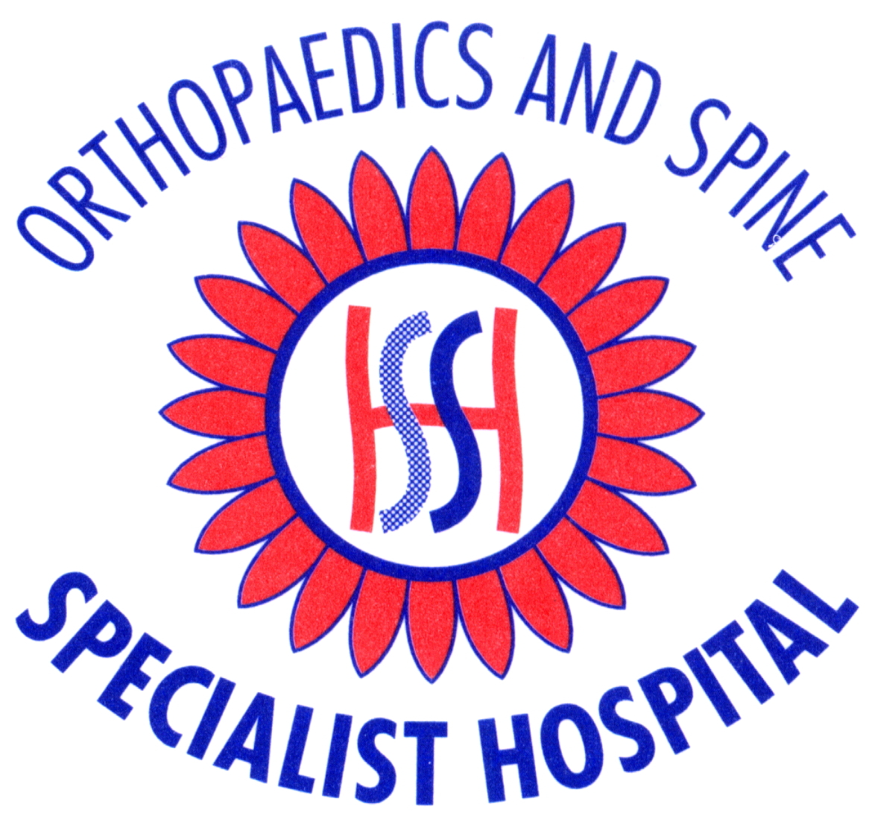
The Orthopaedics and Spine Specialist Hospital

Peterborough

Quality Account
1st April 2023 to 30th April 2024



INDEX

1 | Statement of Quality – Medical Director
2 | Statement of Quality – Registered Manager
3 | Introduction
4 | About Us
5 | Our Principle Areas of Activity
6 | Our Regulators
7 | Care Quality Commission Inspections
8 | The Hospital Medical Advisory Committee (MAC)
9 | Quality Priorities 01.04.23 to 31.03.24
10 | Activity and Quality
11 | Other Reporting and Audits
12 | Looking Forward, our goals
13 | Commissioning for Quality and Innovation CQUIN’s
14 | Mandatory Statement Relating to the Quality of the NHS Services Provided

Welcome to the Orthopaedics and Spine Specialist Hospital’s Quality Account for the period 1st April 2023 to 31st March 2024

- Statement on Quality from the Medical Director, Mr Ahmed Shair, FRCS, MC, Mch, Orth, FRCS Orth

The Orthopaedics and Spine Specialist Hospital is the first independent purpose designed hospital in the UK built exclusively for the treatment of musculoskeletal conditions. The construction of the hospital commenced in 2002 and was completed, registered and authorised by the Healthcare Commission in 2004. Since the hospital opened its doors to the first patient until today it is committed to three interconnected missions:

- Service Mission – to deliver innovative, compassionate and responsive care
- Social Mission – to complement and collaborate with the NHS locally and nationally and make our services available to everyone who needs them, whether privately insured, self funding or NHS patients.
- Business Mission – to run our services on sound business principles that sustain our success and promote the professional and personal development of our staff.

The top areas of our expertise are:

- Treatment of back pain and sciatica
- Hip and knee joint replacements
- Treatment of sports injuries

In the twenty years since the opening of the hospital none of our patients has contracted MRSA and there have been no in-hospital mortalities. The hospital has won awards in Customer Care, hotel services and food hygiene. The hospital is registered and authorised by the Care Quality Commission and approved by the Department of Health as a provider of services to NHS patients and is recognised by most of the UK’s health insurance providers.

In our twentieth year of service my colleagues and I are committed to providing a high quality personal service in a safe and pleasant environment. We believe it is a privilege to be entrusted with the care of our patients therefore we give each patient our utmost consideration and personal attention.

This Quality Account details the actions we have introduced over the past year to maintain and improve the standards our patients are accustomed to expect from us and our hospital has become well known for.

We have an outstanding coherent team who’s professional and personal attributes make it second nature for them to often exceed our patient’s highest expectations.

This Quality Account shows how we assess the quality of our services and hope to share with all stakeholders the milestones of our achievements and our fulfilling of the regulatory and professional standards.

I personally would welcome your feedback or comments. Please contact me on 01733 373057 or send me your written comments to the hospital address Mr Ahmed Shair, Medical Director, The Orthopaedics and Spine Specialist Hospital, 1 Stirling Way, Bretton, Peterborough PE3 8YA

- Statement on Quality from the Registered Manager

Kate Strohman, Registered Manager, Orthopaedics and Spine Specialist Hospital

As the Registered Manager at the Orthopaedics and Spine Specialist Hospital I am proud to be part of a team whose reputation for excellent service and an unprecedented standard of care delivered to our patients, in the field of Orthopaedics, is now firmly established. Our patients are truly at the heart of our organisation and this can be clearly evidenced by the excellent feedback we receive via our patient questionnaire surveys and the number of patient who request referral to us and contact us via recommendation.

Our team of hospital staff are all committed to making the patient’s journey through the hospital as smooth and comfortable as possible. Since the hospital opened in 2004 we have had no incidents of serious hospital acquired infections (MRSA or Clos Dif) and zero cases of inpatient mortalities. Our results show that we constantly deliver against the domains of patient’s safety, procedural effectiveness, and patient positive experience.

We are glad to share the information within this quality report as we believe it is crucial that patients and clinicians should have easy access to this information to make informed choices about where and how they want to be treated.
I am proud of the results shown in this quality account and wish to thank our hospital team who have worked so hard in order to achieve these results.

I declare that the contents of this account has been reviewed and agreed by the hospital’s Medical Advisory Committee.

(Kate Strohman, Registered Manager, Orthopaedics and Spine Specialist Hospital)

- Introduction



The Management of the Orthopaedics and Spine Specialist Hospital are required under the Health Act 2009 and Amendment Regulation 2011 to prepare a Quality Account for each financial year.

In this account we aim to provide readers with clear and concise information on the hospital, our services, our data (the information we gather to evidence the quality, safety and effectiveness of our work) and our patients feedback. This report covers the period 01.04.23 to 31.03.24.

- About Us

The Orthopaedics and Spine Specialist Hospital is a purpose built facility designed for the treatment of patients with orthopaedic/musculoskeletal conditions.

The hospital is a twenty-bed facility with an Outpatient Department, X-ray Department, and state of the art Operating Theatre. The Wards are on the second floor and contains 19 en-suite single bedrooms, one double en-suite room and a Close Observation Suite.



- Our principal areas of activity are:

- Joint replacement – hip and knee
- Spinal surgery for back pain, sciatica, neck pain and brachialgia
- Arthroscopy (both investigative and therapeutic) of knees and other joints
- Foot surgery
- Hand surgery
- Shoulder surgery

- Our Regulators

The Orthopaedics and Spine Specialist Hospital is required to register with the Care Quality Commission and its current registration status is live. The Orthopaedics and Spine Specialist Hospital has no restrictions on registration.

The Care Quality Commission has not taken enforcement action against the Orthopaedics and Spine Specialist Hospital as of 01.04.23 to 31.03.24.

- Care Quality Commission Inspections

Our last two CQC Routine Unannounced inspections and Results

The Orthopaedics and Spine Specialist Hospital is subject to periodic reviews by the Care Quality Commission and the last review was in 2016. The CQC’s assessment of the Orthopaedics and Spine Specialist Hospital following that review was ‘Good’.

Following the visit in 2016 we participate in regular Engagement Calls with the CQC the last of which was in April 2023.

There are no current outstanding actions.

- The Hospital Medical Advisory Committee (MAC)

The hospital has a Medical Advisory Committee (MAC), made up of the Medical Director, Registered Manager and the Clinical Lead Nurse. (There is currently a vacancy for a new lay, Chairperson).

MAC meetings are held where the Medical Director provides an update; we discuss staff movements, clinical governance, staff training and personal development, Care Quality Commission submissions and any other business relating to the running of the organisation.

We accept patients from the private sector insured and self-funding and we also treat patients under our NHS Standard Acute Contract. Our current Commissioners are NHS Peterborough and Cambridgeshire ICB and NHS Lincolnshire ICB.

- Quality Priorities 01.04.23 to 31.03.24.

As we all know the country has been through an unprecedented time during the last few years battling the COVID crisis.

The start of the pandemic made us very quickly set a new priority which was to continue and maintain the delivery of our usual high standard of treatment throughout the pandemic for elective surgery patients.

Apart from one month (May 2020) when we were instructed to close the hospital to elective surgery, we remained open throughout the pandemic delivering patient care and treatment. Using a robust method of testing staff and patients for Covid, maintaining the safety advice issued by the Department of Health together with our usual stringent infection control protocols we succeeded in remaining operational with no reported incidents of COVID within the hospital. We have continued to maintain our usual working practice/routine beyond the COVID pandemic This has resulted in a quality priority met for the period 01.04.23 to 31.03.24.

- Activity and Quality

How many patient contacts in year

In the reporting year 01.04.23 to 30.04.24
we saw:

Day Case Admissions | To April 2024 253
Inpatient Admissions | To April 2024 205
First Outpatient consultations (NHS Patients) | To April 2024 641

Quality indicators

As a provider of health services we gather data to monitor the safety, quality, and effectiveness of our service. We use various mechanisms to collect record and submit this data both internally and to external organisations. For this year’s annual quality report 01.04.23 to 31.03.24 there is a core set of indicators which we are required to report against. Below are the indicators relevant to our organisation including:

- Why we believe the data we are providing is as described
- A brief description of the indicator
- Our plans for improvement going forward.

Quality Indicator 1

Mortality – A death of a patient whilst in our care

The Orthopaedics and Spine Specialist Hospital considers that this data is as described for the following reasons.

Data on mortalities is collected internally. Should a patient die in our care the death would be reported to the Registered Manager who would in turn inform the Care Quality Commission and our NHS Commissioners.

Mortality – A death of a patient in our care whilst in hospital or within 30 days of discharge | Our results
 | Zero
The Orthopaedics and Spine Specialist Hospital intends to take the following actions to improve this rate/percentage and so the quality of its services, by:

OSSH has an exceptionally low rate of patient mortalities. There has been 1 death (2013) recorded since the hospital opened in 2004. This patient’s death was deemed not attributable to her hospital treatment. It will however remain our aim to maintain our current level of patient mortality rates for both inpatients and patients discharged from our care by careful consideration of patients when they are referred, their general health at pre-admission and by applying our usual stringent procedures during surgery postoperatively in hospital and following discharge.

Quality Indicator 2

PROMS

Patient Reported Outcome Measures (Hip and Knee Replacement Surgery)

PROMS are a means of collecting information on the effectiveness of care delivered to NHS patients by the patients themselves. Patients are given a PROMS questionnaire to complete before surgery and then a second questionnaire is sent to the patient approximately 6 months following surgery. The results are collated and published on the NHS Digital website so that the overall outcomes for a particular hospital can be measured against the national average.

The Orthopaedics and Spine Specialist Hospital considers that this data is as described for the following reasons.

At OSSH We ensure that patients are given a PROMS questionnaire at their pre-operative assessment consultation. We have a designated member of our administrative staff who is responsible for explaining the PROMS rationale and process to the patient. Asking the patient to complete the questionnaire whilst they are in the hospital allows us to achieve a high rate of participation (the number of questionnaires completed compared to the number of joint replacements carried out).

NHS Digital publish the official statistics for the year on their website. (Link below) Although they currently have not published a report for the period April 2023 to March 2024 the most recent report is provisional for April 2022 to March 2023.

https://gbr01.safelinks.protection.outlook.com/?url=https%3A%2F%2Fdigital.nhs.uk%2Fdata-and-information%2Fpublications%2Fstatistical%2Fpatient-reported-outcome-measures-proms&data=05%7C02%7Ckatestrohman%40nhs.net%7Ca47ea1d8617c4e3f582f08dc57dd21fe%7C37c354b285b047f5b22207b48d774ee3%7C0%7C0%7C638481854489705461%7CUnknown%7CTWFpbGZsb3d8eyJWIjoiMC4wLjAwMDAiLCJQIjoiV2luMzIiLCJBTiI6Ik1haWwiLCJXVCI6Mn0%3D%7C0%7C%7C%7C&sdata=Ti7mWsLg9%2BC6DxPB7jMXrdw4zDl%2BLHPFjDdyY1KvWCk%3D&reserved=0

Quality Indicator 3

Readmission to hospital within 28 days.

The Orthopaedics and Spine Specialist Hospital considers that this data is as described for the following reasons.

Data on re-admissions to our hospital are compiled by internal methods such as the hospital admission lists, Surgeon notification, ward and theatre admission lists and nursing documentation

Patients who are re-admitted to hospital within 28 days of being discharged. | Our results
 | 2
The Orthopaedics and Spine Specialist Hospital intends to take the following actions to improve this rate/percentage and so the quality of its services, by:

OSSH has a low record of patients being re-admitted to hospital within 28 days of discharge. However we must work to ensure we remain at this level as our volume of work increases. We also aim to monitor closely alerts that patients may have been admitted to another unit, these notifications can come from the patient themselves, the other unit, during our nurses regular follow up telephone calls with patients following discharge and during follow up outpatient consultations. We can then begin to record any incidents of re-admissions to other units and look at the reasons for the readmission. The aim is to look at our procedures to see whether lessons should be learned or our procedures adapted to lessen re-admission’s to hospital.

Quality Indicator 4

This indicator asks about our hospitals responsiveness to the personal needs of its patients.

Each time a patient is admitted to our hospital as a short stay, day case or inpatient we ask them to complete a Patient Satisfaction Survey. The surveys are collected and audited monthly by the hospitals Registered Manager. This allows us to monitor the patient experience and identify any areas where we must produce an action plan to make changes and improve services. The results of the audits are shared and discussed at our regular Medical Advisory Committee meetings and staff meetings.

We are pleased to share in this account the results of our Patient
Satisfaction Surveys for the reporting period 01.04.23 to 30.04.24.

Month | Apr 23 | May 23 | June 23 | July 23 | Aug 23 | Sep 23 | Oct 23 | Nov 23 | Dec 23 | Jan 24 | Feb 24 | Mar 24 | Apr  24
Number of patients treated in hospital | 41 | 40 | 35 | 34 | 39 | 27 | 41 | 41 | 28 | 40 | 33 | 34 | 31
Number of patients who completed a survey | 40 | 39 | 34 | 34 | 39 | 27 | 41 | 41 | 26 | 40 | 33 | 33 | 31
Number of patients who scored the overall service as excellent | 39 | 38 | 31 | 34 | 39 | 27 | 41 | 41 | 25 | 39 | 32 | 33 | 31
Percentage | 97.5% | 97% | 91% | 100% | 100% | 100% | 100% | 100% | 96% | 98% | 97% | 100% | 100%

Quality Indicator 5

Deep vein Thrombosis and Pulmonary Embolism

The Orthopaedics and Spine Specialist Hospital considers that this data is as described for the following reasons.

VTE

Deep vein Thrombosis (DVT) and Pulmonary Embolism (PE) are known under the collective term of venous thromboembolism (VTE). The risk of developing VTE may be increased after undergoing surgery.

All patients admitted to our hospital have a VTE Risk Assessment carried out by their nurse and decisions are made on appropriate prophylaxis. The assessment is kept in the patient’s notes and a monthly audit is carried out by the nurses on the ward. The results of the audit are fed back to the Registered Manager who submits them on Unify2 (an NHS system for reporting hospital data).

The percentage of patients who were admitted to hospital and who were risk assessed for venous thromboembolism (VTE) during the reporting period. | Our results
 | 464 admissions. All were risk assessed for VTE (100%) (from April 23 to April 2024)
The Orthopaedics and Spine Specialist Hospital intends to take the following actions to improve this rate/percentage and so the quality of its services, by:
OSSH aims to continue to strive to maintain that all patients are risk assessed whilst the volume of our work increases.
Quality Indicator 6

Clostridium difficile Infection

Clostridium difficile infection is a type of bacterial infection that can affect the digestive system. It most commonly affects people who have been treated with antibiotics, the symptoms of C. difficile infection can range from mild to severe even possibly fatal, and include, diarrhoea, a high temperature/fever and painful abdominal cramps.

The Orthopaedics and Spine Specialist Hospital considers that this data is as described for the following reasons.

Incidents of infection by C difficile would be identified and reported to the Registered Manager who would follow the Department of Health’s Mandatory Clostridium difficile reporting system.

Patients who have C difficile infection reported within the hospital over the reporting period | Our results
 | 0
The Orthopaedics and Spine Specialist Hospital intends to take the following actions to improve this rate/percentage and so the quality of its services, by:

OSSH has an exceptionally low rate of infection; we will continue to put into practice our present procedures to maintain this level whilst the volume of our work increases.

Quality Indicator 7

Accidents, Incidents and near misses

A patient safety incident is any unintended or unexpected incident which could have or did lead to harm for one or more patients receiving NHS care.

The Orthopaedics and Spine Specialist Hospital considers that this data is as described for the following reasons.

The hospital has a policy and procedure for Patient Safety Incidents, and the steps to follow in the event of an incident are incorporated into our staff training sessions. For any serious incident an Incident Report form must be completed and passed to the Registered Manager who is responsible for informing the Care Quality Commission and NHS Commissioners.
The number and rate of patient safety incidents reported during the reporting period and the number of such incidents that resulted in severe harm or death | Our results
 | 2 reportable incident no severe harm or death suffered.
The Orthopaedics and Spine Specialist Hospital intends to take the following actions to improve this rate/percentage and so the quality of its services, by:
The Orthopaedics have had 2 such incidents since the hospital opened in 2004, again we will continue to strive to achieve zero incidences whist the volume of our work increases.



Quality Indicator 8

Friends and Family

The Friends and Family initiative involves us asking our day case and inpatients a set of very specific questions. These questions must be presented to the patient before our in-house patient satisfaction survey so they are the first questions the patient sees.

The Orthopaedics and Spine Specialist Hospital considers that this data is as described for the following reasons.

The Friends and Family Test (FFT) is a survey which asks patients whether they would recommend the NHS service they have received to friends and family who need similar treatment or care. Patients are asked to answer the following question:

‘We welcome patient feedback to tell us what we ae doing right and what we can improve. Thinking about the Orthopaedics and Spine Specialist Hospital’

Overall, how was your experience of our service?
Friends and Family Results for the reporting period 01.04.23 to 31.03.24

Month | Apr  23 | May 23 | June 23 | July 23 | Aug 23 | Sep 23 | Oct 23 | Nov 23 | Dec 23 | Jan 24 | Feb 24 | Mar  24 | Apr  24
No. of patients | 41 | 39 | 29 | 27 | 36 | 27 | 36 | 34 | 28 | 40 | 33 | 34 | 31
No. of returns | 41 | 39 | 29 | 27 | 36 | 27 | 36 | 34 | 26 | 40 | 33 | 33 | 31
Q1. Very Good | 41 | 39 | 29 | 27 | 36 | 27 | 36 | 34 | 26 | 40 | 33 | 32 | 31
Q2. Good | 0 | 0 | 0 | 0 | 0 | 0 | 0 | 0 | 0 | 0 | 0 | 1 | 0
Q3. Neither good nor poor | 0 | 0 | 0 | 0 | 0 | 0 | 0 | 0 | 0 | 0 | 0 | 0 | 0
Q4. Poor | 0 | 0 | 0 | 0 | 0 | 0 | 0 | 0 | 0 | 0 | 0 | 0 | 0
Q5. Very poor | 0 | 0 | 0 | 0 | 0 | 0 | 0 | 0 | 0 | 0 | 0 | 0 | 0
Q6. Don’t know | 0 | 0 | 0 | 0 | 0 | 0 | 0 | 0 | 0 | 0 | 0 | 0 | 0
Percentage | 100% | 100% | 100% | 100% | 100% | 100% | 100% | 100% | 100% | 100% | 100% | 97% | 100%

- Other reporting and Audits

The hospital has a robust schedule of audits, inspections, and data submission requirements which we outline below:

Integrated Care Board Quality Report | Monthly
Nursing Documentation | Monthly
Infection Control Audit | Quarterly
Infection Control Inspection/Audit | Annually
Health and Safety Audit | Quarterly and annually
Patient Survey Audits | Monthly
Pain Control Audits | Monthly
Medicine Management | Every 6 months
Mattress Audit | Quarterly
Friends and Family Audit | Monthly
Friends and Family data submission | Submitted monthly
PROMS (Patient Reported Outcome Measures) knee and hip replacement surgery | Submitted monthly
National Joint Registry data submission | Submitted Weekly
British Spine Registry data submission | Submitted Weekly
Operating Theatre World Health Association (WHO) audit | Monthly
Referral to Treatment data submission | Monthly
Monthly Referral Runs (MRR) data submission | Monthly

Monthly and quarterly audits are carried out by the nursing staff the results are passed to the Registered Manager who compiles the information into a format that can be presented at the MAC and staff meetings. Annual audits are carried out by independent consultants. The results of the audits are available for inspection by the Care Quality Commission and our Commissioners.

National Joint Registry

The National Joint Registry records details of joint replacement operations to monitor the results of joint replacement surgery and protect patient safety.

Below are the latest available results from the National Joint Registry This is for a rolling 12 months.

- Consent rate for hospital. Percentage of cases submitted to the NJR with patient consent confirmed. The benchmark figure is 95%.
- Linkability for hospital. Percentage of cases submitted to the NJR with NHS numbers supplied or identifiable through other supplied data. The benchmark figure is 95%.

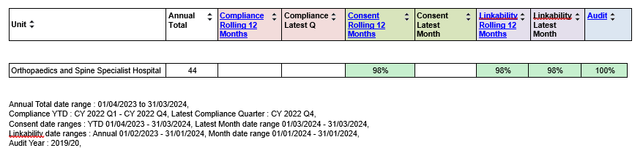

We are pleased to have received the National Joint Registry certificate as a Quality Data Provider for 2020/21 and 2021/22.

- Looking Forward, Our Goals

Working towards a paper free environment

Currently we are very much a paper based organisation. We intend to work towards reducing paper activities to achieve:

- Cost savings and space efficiency
- Streamlining processes
- Environmental impact
- Improved accessibility
- Patient self service

Collection of additional Patient information on registration

We have identified that we can gather more information when a patient registers at our hospital. This will allow us to ensure that we are offering our services to a wide range of patients and that we can tailor our service to meet the needs of our patient population.

Whether a patient chooses to provide their data is optional.

We will start to collect:

- MX will be added as a title choice
- Gender will include:
- Male inc. Trans Men
- Female inc. Trans Women
- Non-Binary
- Other

Which of the following best describes you:

- Heterosexual/straight
- Gay/lesbian
- Bisexual
- Prefer not to say
- In any other way

We will increase the options for disabilities and religions and we will offer the patient the option of providing someone’s name and contact details and permission to speak to the third party on their behalf.
- Commissioning for Quality and Innovation (CQUINS)

The Orthopaedics and Spine Specialist Hospital’ income in the period 1st April 2023 to 31st March 2024 was not conditional on achieving quality improvement and innovation goals through the CQUIN payment framework because the National NHS CQUINS framework ceased in 2020/21.



- Mandatory Statement Relating to the Quality of NHS Services Provided

The following section contains the mandatory statements common to all Quality Accounts as required by the regulations set out by the Department of Health (DH).

During 1st April 2023 to 31st March 2024 the Orthopaedics and Spine Specialist Hospital provided and/or sub-contracted one NHS service.

The Orthopaedics and Spine Specialist Hospital has reviewed all the data available to them on the quality of care in one of these NHS services.

The income generated by the NHS service reviewed in 1st April 2023 to 31st March 2024 represents 81% of the total income generated from the provision of NHS services by the Orthopaedics and Spine Specialist Hospital (reporting period).

During 1st April 2023 to 31st March 2024 zero national clinical audits and zero confidential enquiries covered NHS services that the Orthopaedics and Spine Specialist Hospital provides.

The number of patients receiving NHS services provided or sub-contracted by the Orthopaedics and Spine Specialist Hospital in 1st April 2023 to 31st March 2024 that were recruited during that period to participate in research approved by the ethics committee was (0).

The Orthopaedics and Spine Specialist Hospital submitted records during 1st April 2023 to 31st March 2024 to the Secondary Uses Service for inclusion in the Hospital Episode Statistics which are included in the published data. The percentage of records in the published data:

- Which included the patient’s valid NHS number was:
100% for admitted patient care;
100% for out patient care;
And
N/A for accident and emergency care.

- Which included the patient’s valid General Medical Practice Code was;
100% for admitted patient care;
100% for out patient care;
And
N/A for accident and emergency care.

The Orthopaedics and Spine Specialist Hospital score for 1st April 2023 to 31st March 2024 for Information Quality and Records Management, assessed using the Information Governance Toolkit was ‘Standard Met’.

The Orthopaedics and Spine was not subject to the Payment by Results clinical coding audit during 1st April 2023 to 31st March 2024 by the Audit Commission.

